# Extracting Data and Creating Dataset for SPB Dashboards Creation

The purpose of this document is to provide the details on the dashboard for funnel metrics.

*Scenarios:*

* SPB Search - Sponsored Brand Product (Offer Search)
* SPB PDP - Sponsored Brand Product (Product Data Page)

*Event Used:*

* edgeflyoutstatusevent
* spbadsresponseevent
* icrequestevent
* comparableoffersrequestresponseevent

Metrics:

SPB Search

1. ActualClientRequests
2. AdsRequest
3. TotalAdsResponse
4. TotalAdsResponseWithCashback
5. Impressions
6. ShownInPane
7. ShownInNotification
8. ActivateClicks
9. ActivateClickedInPane
10. ActivateClickedInNotification
11. Hovers

Dashboard Charts:

*Dashboard daily view*

Dashboard Link – [EdgeShoppingSPBSearch (azure.com)](https://dataexplorer.azure.com/dashboards/53186df8-a4c1-4daa-9977-7bd4ebcd499b?p-_startTime=365days&p-_endTime=now#34b7cb3b-3db1-44d6-b1a8-6e4a05e29594)

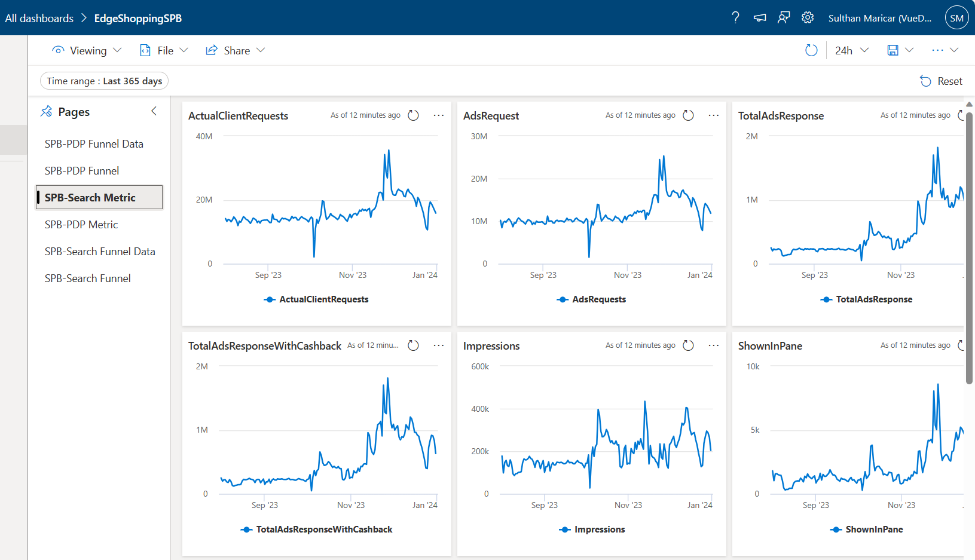

*SPB Search Funnel Aggregate view:*

Funnel view – Daily / Monthly / Yearly

1. ActualClientRequests
2. AdsRequests
3. TotalAdsResponse
4. TotalAdsResponseWithCashback
5. Impressions
6. ShownInNotification
7. Hovers
8. Activate Clicks
9. ShownInPane
10. ActivateClickedInPane
11. ActivateClickedInNotification

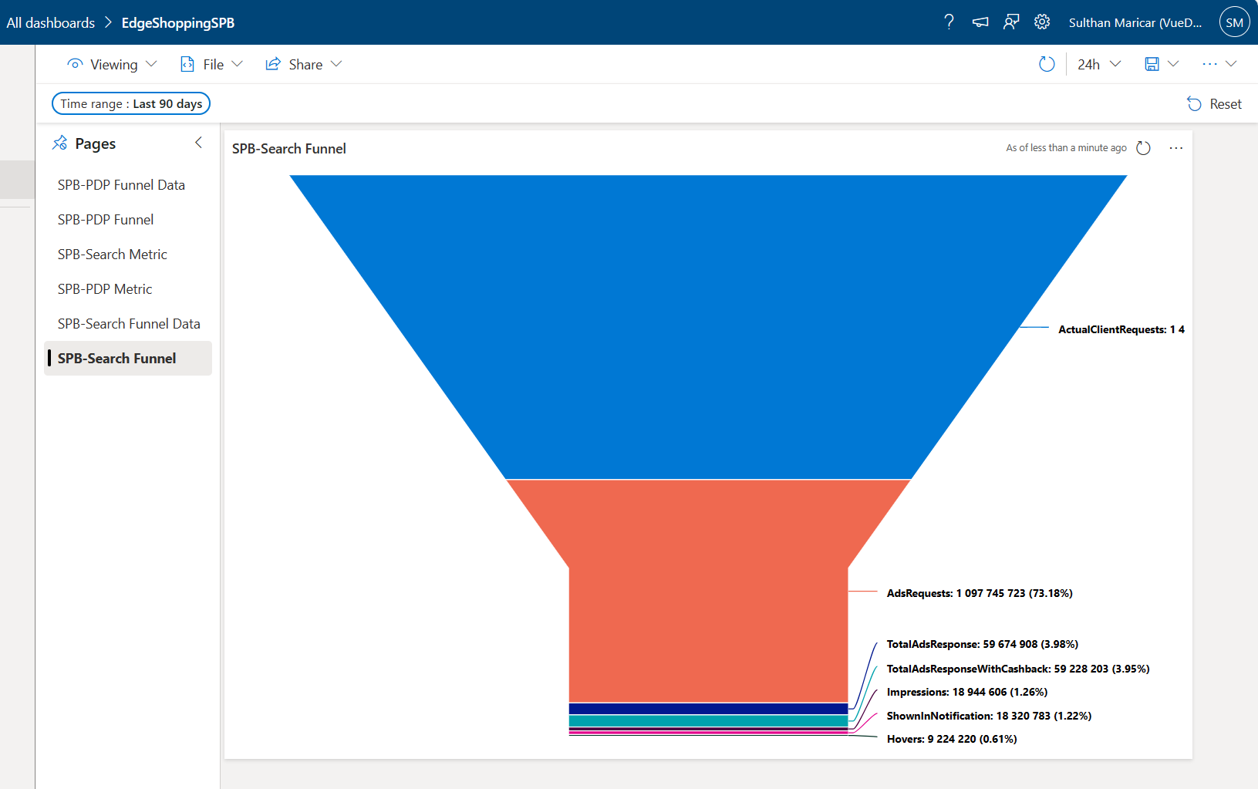

*SPB Search Funnel Aggregate view:*

Funnel Data Table view – Daily / Monthly / Yearly

1. ActualClientRequests
2. AdsRequests
3. TotalAdsResponse
4. TotalAdsResponseWithCashback
5. Impressions
6. ShownInNotification
7. Hovers
8. Activate Clicks
9. ShownInPane
10. ActivateClickedInPane
11. ActivateClickedInNotification

File Location:

Cosmos path shared location:

*Cluster: cosmos08-prod-co3c*

*Virtual Cluster: ugc-prod*

*SPB-Search*Path: [cosmos08 ugc-prod cosmos/ugc-prod/local/Cashback/Metrics/SPBScenario/SPB-Search/TSV/2023/ (osdinfra.net)](https://www.cosmos08.osdinfra.net/cosmos/ugc-prod/local/Cashback/Metrics/SPBScenario/SPB-Search/TSV/2023/)

*Path Structure*:

**Structure:** Local / Cashback / Metrics / <ScenarioName> / <Sub Scenario Name> / <File Format> / <Year> / <Month> / FileName_YYYY_MM_DD.tsv  
  
**Example:** Local/ Cashback / Metrics / SPBScenario / SPB-Search / TSV / 2023 / 12 / spb_search_2023_12_01.tsv  
  
**Safety:** Local/ Cashback / Metrics / SPBScenario / SPB-Search / TSV / 2023 / 12 / latest.tsv  
  
  
Metrics:

SPB PDP

1. TotalRequest
2. TotalSpbPdpRequest
3. TotalSpbDomainRequests
4. TotalSpbSupply
5. MaxPossibleDemand
6. SpbPdpFlightDemand
7. MinimumExpectedSpbResponse
8. AdsResponse
9. AutoShowEnabled
10. Impressions
11. MVMILogged
12. ActivateClicks

SPB PDP Flight Metrics:

1. TotalSPBFlightDomainsRequestPDPsInMMC
2. TotalDistinctRequestPdpsInMMC

Dashboard Charts:

*Dashboard daily view*

Dashboard Link – [EdgeShoppingSPBPDP (azure.com)](https://dataexplorer.azure.com/dashboards/53186df8-a4c1-4daa-9977-7bd4ebcd499b?p-_startTime=90days&p-_endTime=now#8fee88b1-4e6d-411a-91ce-4e74dee10ad8)

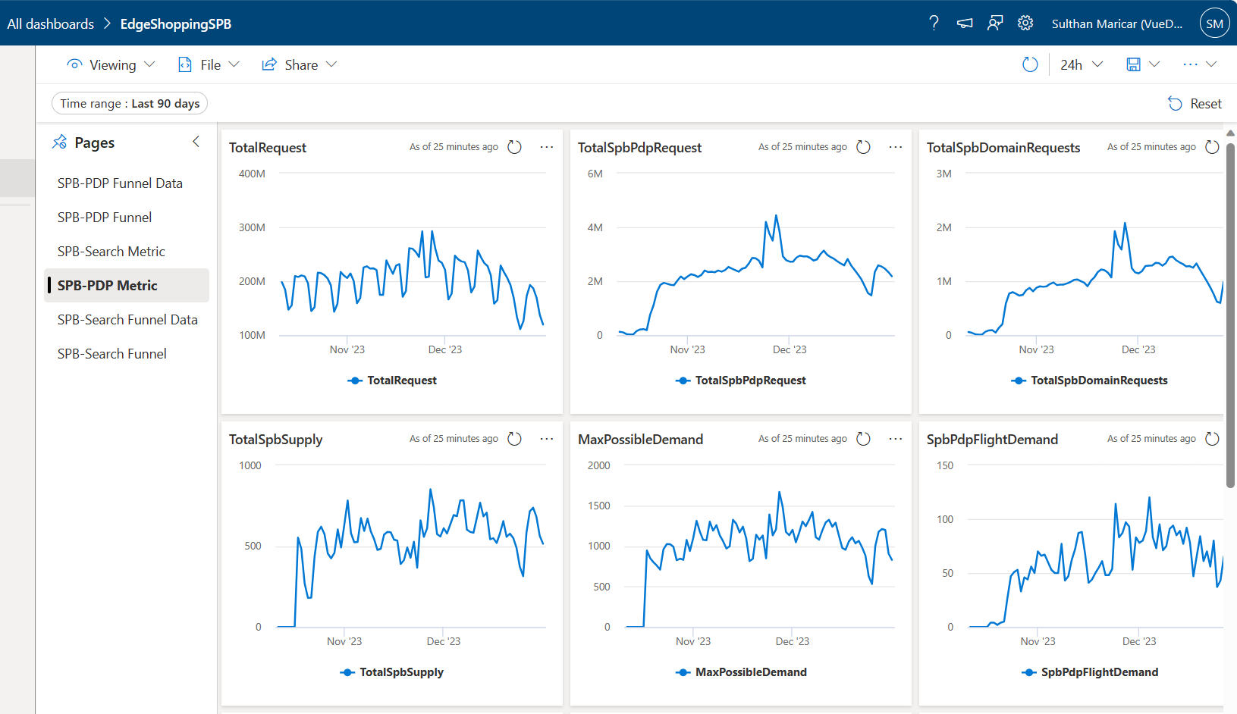

*SPB PDP Funnel Aggregate view:*

Funnel view – Daily / Monthly / Yearly

1. TotalRequest
2. TotalSpbPdpRequest
3. TotalSpbDomainRequests
4. MaxPossibleDemand
5. TotalSpbSupply
6. AdsResponse
7. AutoShowEnabled
8. Impressions
9. MVMILogged
10. SpbPdpFlightDemand
11. MinimumExpectedSpbResponse
12. ActivateClicks

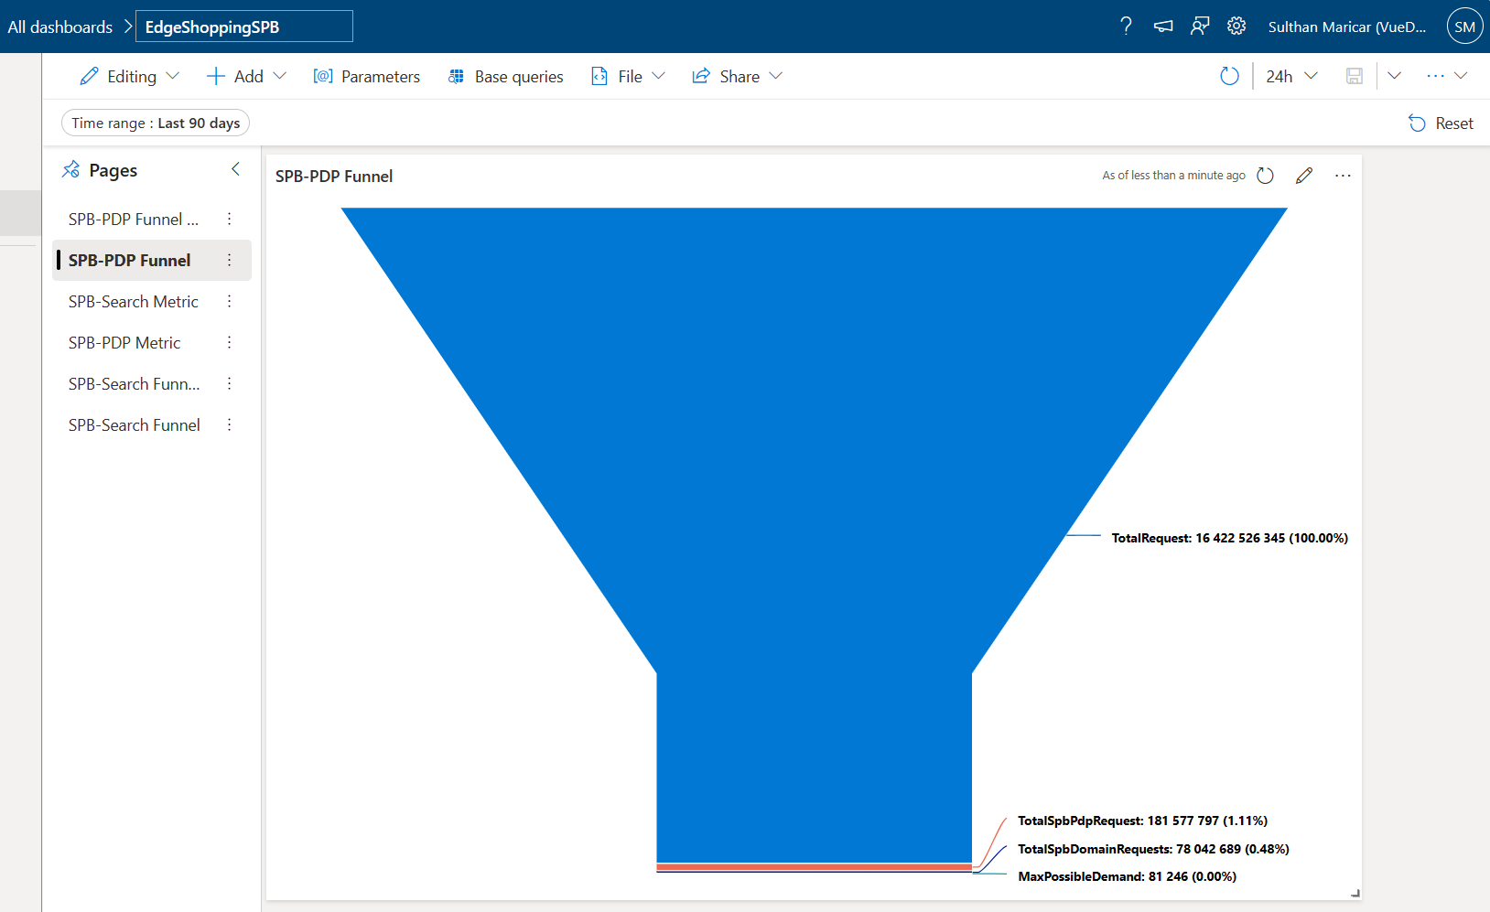

*SPB PDP Funnel Aggregate view:*

Funnel Data Table view – Daily / Monthly / Yearly

1. TotalRequest
2. TotalSpbPdpRequest
3. TotalSpbDomainRequests
4. MaxPossibleDemand
5. TotalSpbSupply
6. AdsResponse
7. AutoShowEnabled
8. Impressions
9. MVMILogged
10. SpbPdpFlightDemand
11. MinimumExpectedSpbResponse
12. ActivateClicks

File Location:

Cosmos path shared location:

*Cluster: cosmos08-prod-co3c*

*Virtual Cluster: ugc-prod*

*SPB-PDP*Path: [cosmos08 ugc-prod cosmos/ugc-prod/local/Cashback/Metrics/SPBScenario/SPB-PDP-Funnel/TSV/2023/12/ (osdinfra.net)](https://www.cosmos08.osdinfra.net/cosmos/ugc-prod/local/Cashback/Metrics/SPBScenario/SPB-PDP-Funnel/TSV/2023/12/)

*Path Structure*:

**Structure:** Local / Cashback / Metrics / <ScenarioName> / <Sub Scenario Name> / <File Format> / <Year> / <Month> / FileName_YYYY_MM_DD.tsv  
  
**Example:** Local/ Cashback / Metrics / SPBScenario / SPB-PDP-Funnel / TSV / 2023 / 12 / spb_pdp_2023_12_01.tsv  
  
**Safety:** Local/ Cashback / Metrics / SPBScenario / SPB-PDP-Funnel / TSV / 2023 / 12 / latest.tsv

Cosmos path shared location:

*Cluster: cosmos08-prod-co3c*

*Virtual Cluster: retail.catalog  
  
Path:*[cosmos08 retail.catalog cosmos/retail.catalog/local/Cashback/Metrics/SPBScenario/SPB-PDP/TSV/2024/01/ (osdinfra.net)](https://www.cosmos08.osdinfra.net/cosmos/retail.catalog/local/Cashback/Metrics/SPBScenario/SPB-PDP/TSV/2024/01/)**Structure:** Local / Cashback / Metrics / <ScenarioName> / <Sub Scenario Name> / <File Format> / <Year> / <Month> / FileName_YYYY_MM_DD.tsv  
  
**Example:** Local/ Cashback / Metrics / SPBScenario / SPB-PDP / TSV / 2024 / 01 / spb_pdp_flight_2024_01_10.tsv

*Dashboard Linking:*

File Input:

* Getting input from the cluster cosmos08 and “ugc-prod-c08” VC.
* In cosmos path, Data are in “log_bucket” format.

Conversion:  
  
Attached the scope scripts for SPB Search and SPB PDP, It extracts the data from cosmos path log_bucket file into expected result in TSV format.

SPB Search Script:  
  
  
  
SPB PDP Scope Script:  
  


* Using this scope script, we can handle all the logical calculations and convert the data into required formats like TSV or structured stream.
* Once the logic part is done, we can store it in one cosmos path.

Ingestion to Kusto: Using Azure Data Factory

* Create a pipeline of a new linked service in ADF using the below image. You can select your desired database.  
    
  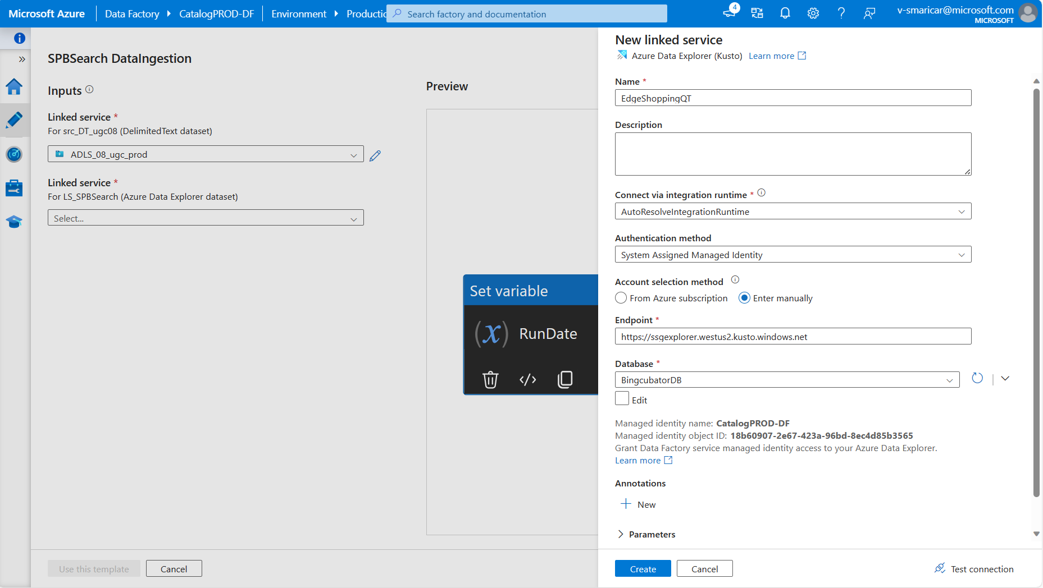
* In Source, we need to update the Wildcard path, where our scripts are located and update the file format like "daubydomainupdated_*.tsv" it will ingest the data into Kusto.   
  A screenshot of a computer

  Description automatically generated
* Once you click on the Wildcard path, here you can update the script path and click ok.  
    
  A screenshot of a computer

  Description automatically generated
* In Sink tab, you can update your Kusto table, where you want to ingest the data.  
    
  A screenshot of a computer

  Description automatically generated
* If you want to change your table, Click on “Open”.  
    
  A screenshot of a computer

  Description automatically generated
* Uncheck “Enter manually”, Select your table then again select checkbox.
* In Kusto, first you need to create a table with the respective column in script.  
    
  A screenshot of a computer

  Description automatically generated
* You need to verify your connection first, so select “Test connection”.
* If the connection was successful, Select Schema tab.  
    
  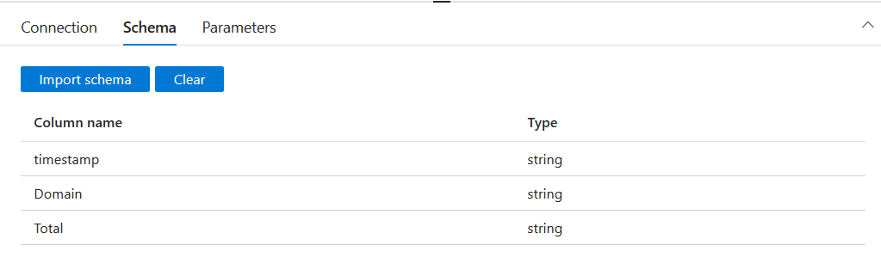

* First you need to Clear the existing table column first, then Click on Import schema.
* Now you can see the selected table columns.
* Then click on this previous tab and now select Mapping tab.  
    
  A screenshot of a computer

  Description automatically generated
* In Mapping, you need to “Clear” the existing mapping columns. Then select “Import schemas” to mapping the latest column.
* You need to verify that both “Source” & “Destination” looks same, without any column or type changes.
* When you select the “Import schemas” it asks you to enter pipeline run date, Enter the run date for the script which is available on this date.  
    
  A screenshot of a computer

  Description automatically generated
* Adding scope script into the pipeline, In “Activities” you search “scope” you get the scope icon in “Data Lake Analytics”.
* Drag and drop the scope and hover the “Scope” you can able to see tick icon on right side.
* Drag and drop the tick icon into Set variable tab to connect into it.  
    
  A screenshot of a computer

  Description automatically generated  
  In the “Script” tab, you can add your script path and script name. Test connection once you added the script.  
    
  A screenshot of a computer

  Description automatically generated  
    
  In “ADLA Account”, Select your VC where you script file is located.  
    
  A screenshot of a computer

  Description automatically generated
* Then click on “Debug”, Again it asks you for Pipeline run date. You need to give the run date for which monthly date files you want to ingest.
* After that you can see the ingestion process below. Once the ingestion process was completed. You can check the records on the Kusto table.  
    
  A screenshot of a computer

  Description automatically generated

Dashboard:

* Once we have the data for all the datasets, we can start creating the dashboard and charts.

How to fix the errors in pipeline failure:

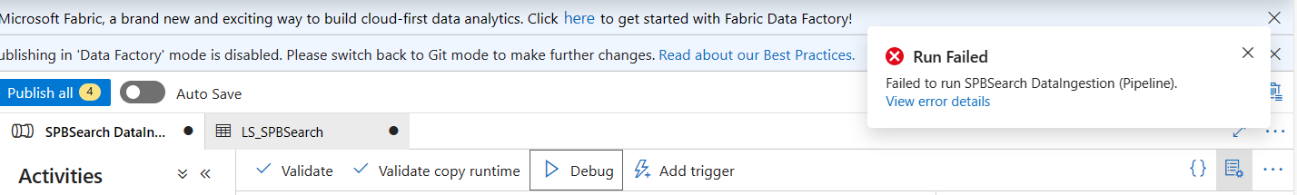

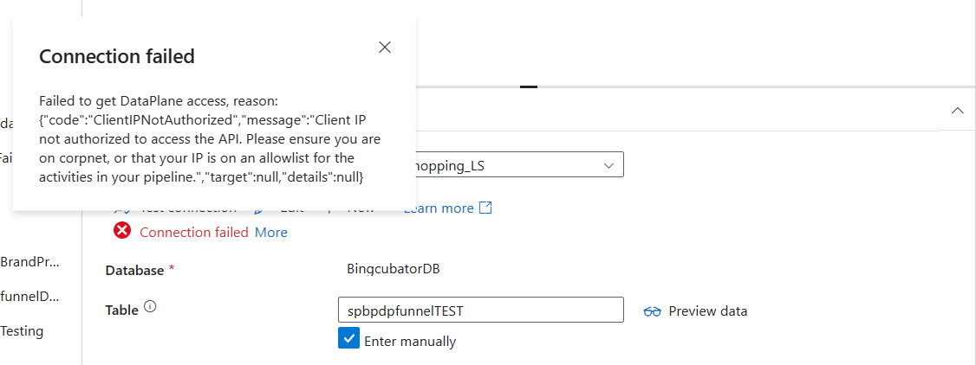

Follow the steps to fix the error:

1. You need to close the edge browser.
2. Disconnect the MSFT-VPN then again Reconnect the MSFT-VPN.
3. Open command prompt in administrator mode
4. Run the command: “nslookup management.azure.com”.
5. Run the command: “ipconfig”
6. Run the command: “route -p add 40.78.196.33 mask 255.255.255.255 <<your ip>>”  
     
   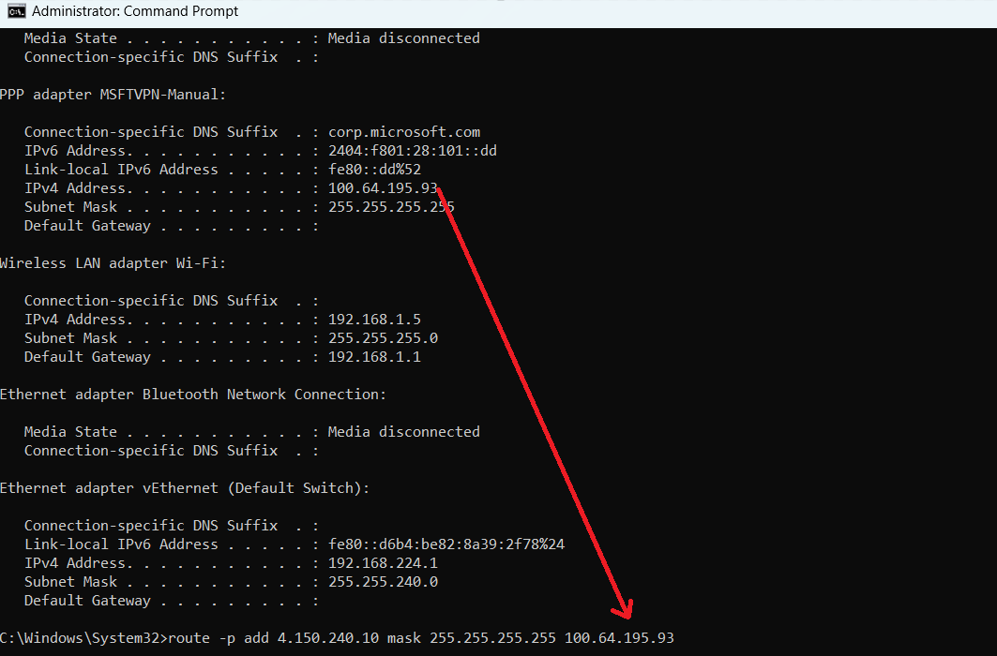
7. You can get <<your ip>> from MSFT-VPN address in command prompt.
8. Still if you face the error, Run the command: “route -p delete 40.78.196.33”
9. Run the command: route -p add 4.150.240.10 mask 255.255.255.255 <<your ip >>
10. Open the edge browser and Redirect into [Azure Data Factory](https://ms-adf.azure.com/en/authoring/pipeline/QT%20DataIngestion?factory=%2Fsubscriptions%2Ff3f7bc33-086d-473a-ad71-cca05dc8dfb8%2FresourceGroups%2FcatalogINT%2Fproviders%2FMicrosoft.DataFactory%2Ffactories%2FCatalogPROD-DF)

How to fix this mapping issue:

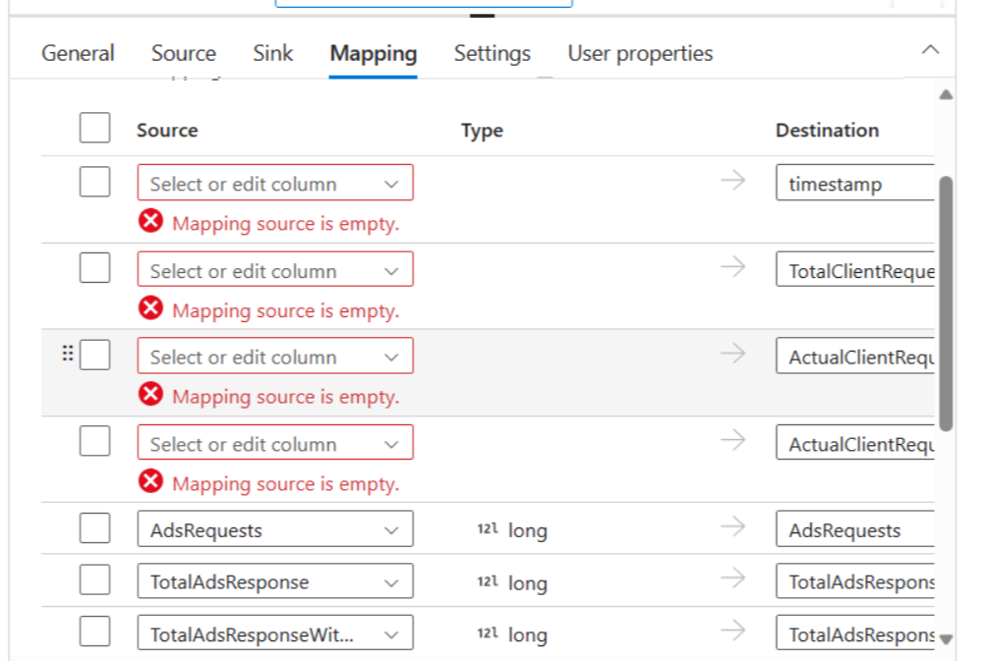

Need to check the “Source” column type and “Sink” column type, If any of the column type changed.   
  
Example: timestamp as string in “Source” & datetime in “Sink”. You got mapping issue.  
  
If you’re try to map with different dataset as well, You got the mapping issue.  
  
Example: “Source” pointed to spb_pdp dataset but in “Sink” you’re selected spb_search dataset then Mapping will be failed.

Reference Link:

* Cluster Name: ssgexplorer
* Cluster URL: [https://ssgexplorer.westus2.kusto.windows.net](https://nam06.safelinks.protection.outlook.com/?url=https%3A%2F%2Fssgexplorer.westus2.kusto.windows.net%2F&data=05%7C01%7Cv-smaricar%40microsoft.com%7Cce2c56954bb24457575708dbe593f96f%7C72f988bf86f141af91ab2d7cd011db47%7C1%7C0%7C638356195977282446%7CUnknown%7CTWFpbGZsb3d8eyJWIjoiMC4wLjAwMDAiLCJQIjoiV2luMzIiLCJBTiI6Ik1haWwiLCJXVCI6Mn0%3D%7C3000%7C%7C%7C&sdata=RiVUBUe2fFOhbPFuREe%2B3DQl%2FJ%2F0kvpB6Bv%2FbsvMA8w%3D&reserved=0)
* Event Name: edgeflyoutstatusevent
* Event URL: [EdgeFlyoutStatusEvent](https://www.cosmos08.osdinfra.net/cosmos/ugc-prod/shares/ugc-prod/AriaLogs/EdgeShopping/prd/edgeflyoutstatusevent/2023/11/)
* Event Name: edgereceiptsubmitevent
* Event URL: [EdgeReceiptSubmitEvent](https://www.cosmos09.osdinfra.net/cosmos/NewExp/shares/NewExp/Aria-Groceries/GroceriesLogs/prd/edgereceiptsubmitevent/2023/10/)
* Event Name: spbadsresponseevent
* Event URL: [SPBAdsResponseEvent](https://www.cosmos08.osdinfra.net/cosmos/ugc-prod/shares/ugc-prod/AriaLogs/EdgeShopping/prd/spbadsresponseevent/2023/11/)
* Event Name: icrequestevent
* Event URL: [ICRequestEvent](https://www.cosmos08.osdinfra.net/cosmos/ugc-prod/shares/ugc-prod/AriaLogs/EdgeShopping/prd/icrequestevent/2023/11/)
* Event Name: comparableoffersrequestresponseevent
* Event URL: [ComparableOffersRequestResponseEvent](https://www.cosmos08.osdinfra.net/cosmos/ugc-prod/shares/ugc-prod/AriaLogs/EdgeShopping/prd/comparableoffersrequestresponseevent/2023/11/)
* Dashboard Name: SPB Search Metric
* Dashboard URL: [SPBSearchMetricDashboard](https://dataexplorer.azure.com/dashboards/53186df8-a4c1-4daa-9977-7bd4ebcd499b?p-_startTime=90days&p-_endTime=now#34b7cb3b-3db1-44d6-b1a8-6e4a05e29594)
* Dashboard Name: SPB PDP Metric
* Dashboard URL: [SPBPDPMetricDashboard](https://dataexplorer.azure.com/dashboards/53186df8-a4c1-4daa-9977-7bd4ebcd499b?p-_startTime=90days&p-_endTime=now#8fee88b1-4e6d-411a-91ce-4e74dee10ad8)
* Dashboard Name: SPB Search Funnel
* Dashboard URL: [SPBSearchFunnelDashboard](https://dataexplorer.azure.com/dashboards/53186df8-a4c1-4daa-9977-7bd4ebcd499b?p-_startTime=90days&p-_endTime=now#daad07d4-9220-410e-8ded-bd78f9afcae5)
* Dashboard Name: SPB PDP Funnel
* Dashboard URL: [SPBPDPFunnelDashboard](https://dataexplorer.azure.com/dashboards/53186df8-a4c1-4daa-9977-7bd4ebcd499b?p-_startTime=90days&p-_endTime=now#2ccdcfb6-5b69-4b00-9c0c-6cd25dfacef1)
* Dashboard Name: SPB Search Funnel Table Data
* Dashboard URL: [SPBSearchFunnelTableData](https://dataexplorer.azure.com/dashboards/53186df8-a4c1-4daa-9977-7bd4ebcd499b?p-_startTime=90days&p-_endTime=now#05b15e95-2e04-4ed5-b30b-424bed705feb)
* Dashboard Name: SPB PDP Funnel Table Data
* Dashboard URL: [SPBPDPFunnelTableData](https://dataexplorer.azure.com/dashboards/53186df8-a4c1-4daa-9977-7bd4ebcd499b?p-_startTime=90days&p-_endTime=now#48e47138-826e-4e55-a26e-695afff5e759)
* Dashboard List: Azure Data Explorer All Dashboard
* Dashboard URL: [All Dashboards](https://dataexplorer.azure.com/dashboards/)